# Supplementary:

## Supplementary figures:

**SUPPLEMENTARY Fig 1. Correlations between telomere length, peripheral white blood cells, and lymphocytes.** Mean telomere length (Telo-FISH) plotted longitudinally against peripheral white blood cell (WBC) counts (thousands per microliter) from complete blood count tests for all patients; and longitudinal correlations between mean telomere length and counts of WBC types, and proportions of lymphocyte cell types. 1 non irrad: pre-IMRT non-irradiated; 3 B: immediate post-IMRT; 4 C: 3 months post-IMRT. Pearson correlation R2 values were calculated between longitudinal values, as shown bolded in (A), on a per patient basis. Correlations between mean telomere length and WBC counts **A**); center lines denote medians, lighter bands denote confidence intervals. Correlations between mean telomere length and five main WBC types **B**), and proportions of lymphocyte cell types **C**).

**SUPPLEMENTARY Fig 2. Correlations between chromosome aberrations and peripheral blood lymphocytes.** Average frequencies of chromosome aberrations plotted longitudinally against lymphocyte cell counts (thousands per microliter) from complete blood count tests for all patients. 1 non irrad: pre-IMRT non-irradiated; 3 B: immediate post-IMRT; 4 C: 3 months post-IMRT. Excess chr fragments: counts of chromosome fragments per cell after subtracting 1 count per n observed dicentrics. Center lines denote medians, lighter bands denote confidence intervals. Pearson correlation R2 values were calculated between plotted values on a per patient basis and noted in bold on each graph. **A**) Inversions, **B**) translocations, **C**) dicentrics, **D**) chromosome fragments and lymphocyte cell counts.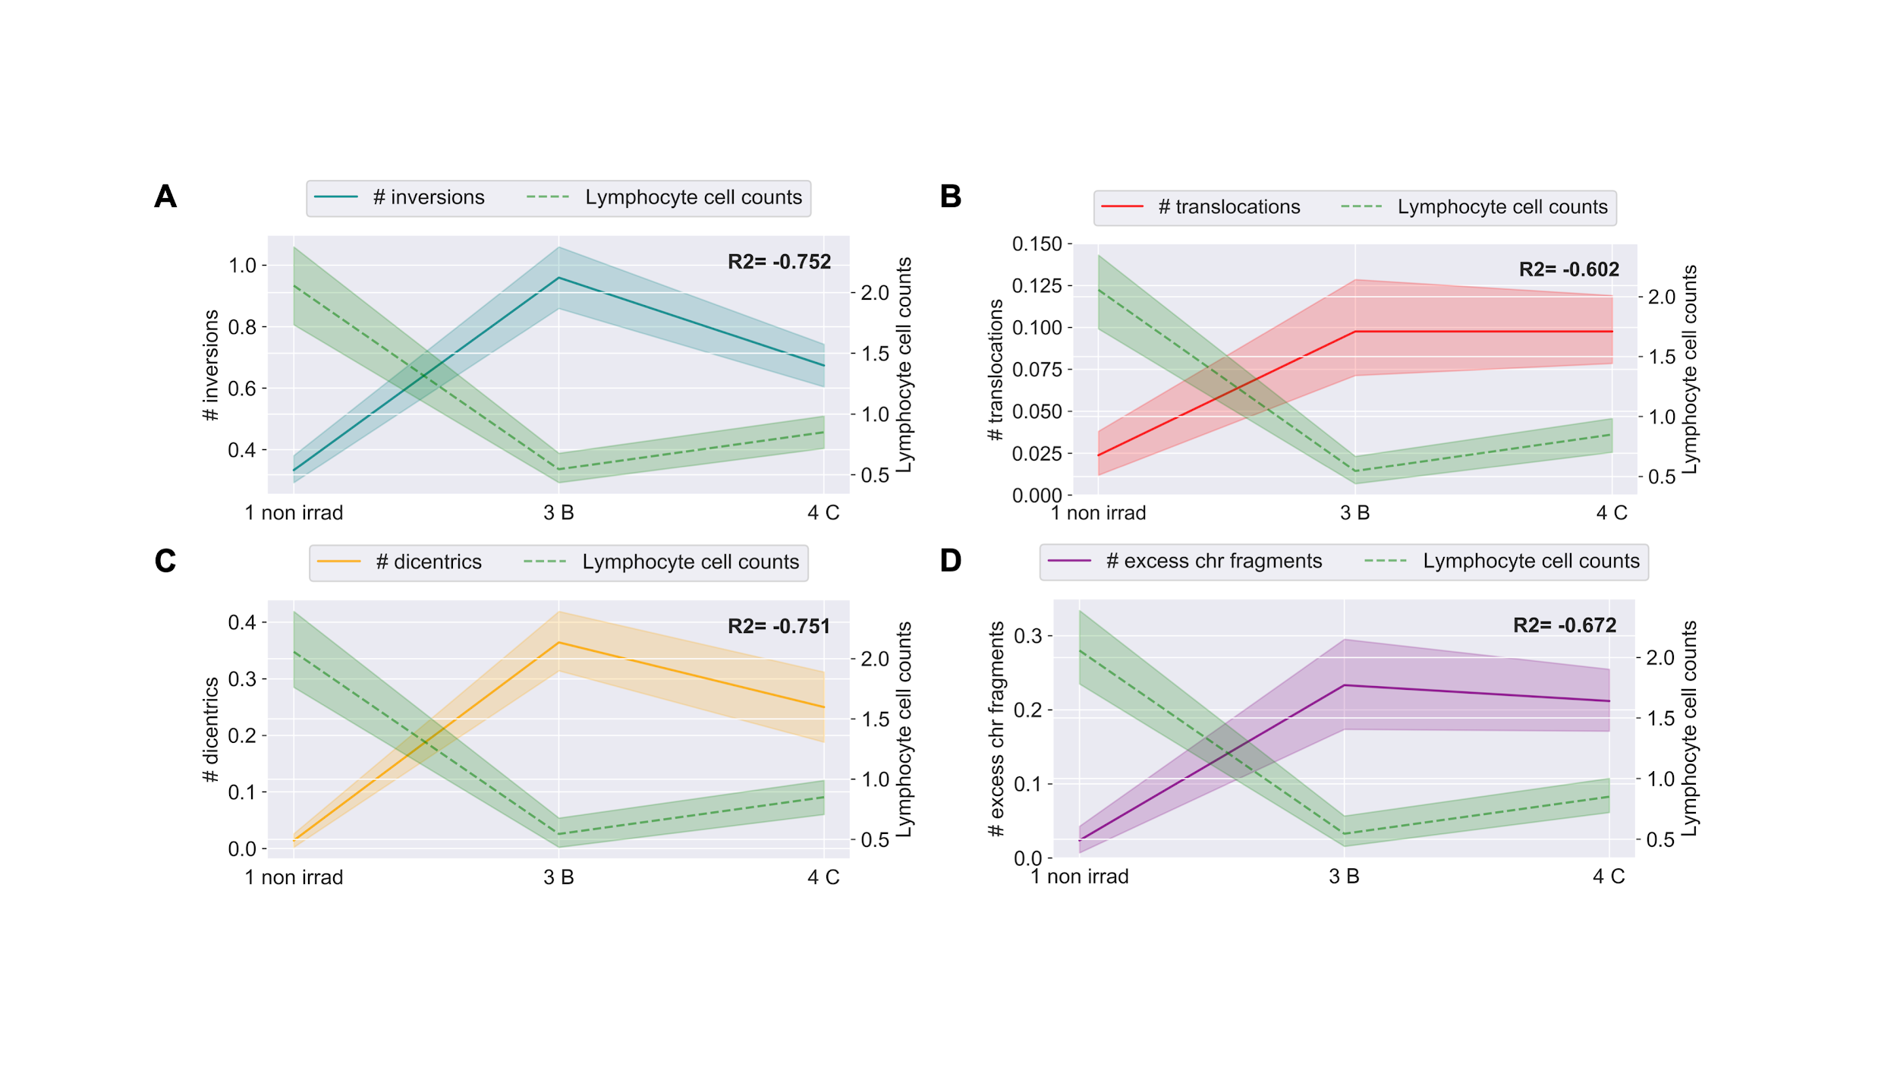

**SUPPLEMENTARY Fig 3. Clustering of patients by inversions and chromosome fragments (deletions).** Hierarchical clustering of patients by longitudinal changes in chromosome aberrations scored by directional Genomic Hybridization (dGH). 1 non irrad: pre-IMRT non-irradiated; 2 irrad @ 4 Gy: pre-IMRT *in vitro* irradiated; 3 B: immediate post-IMRT; 4 C: 3 months post-IMRT. Excess chr fragments: counts of chromosome fragments per cell after subtracting 1 count per n observed dicentrics. Patients were clustered by inversions **A**) and chromosome fragments **B**) (z-score normalized). Patient ID 13 not clustered; 3 months post-IMRT sample failed to culture.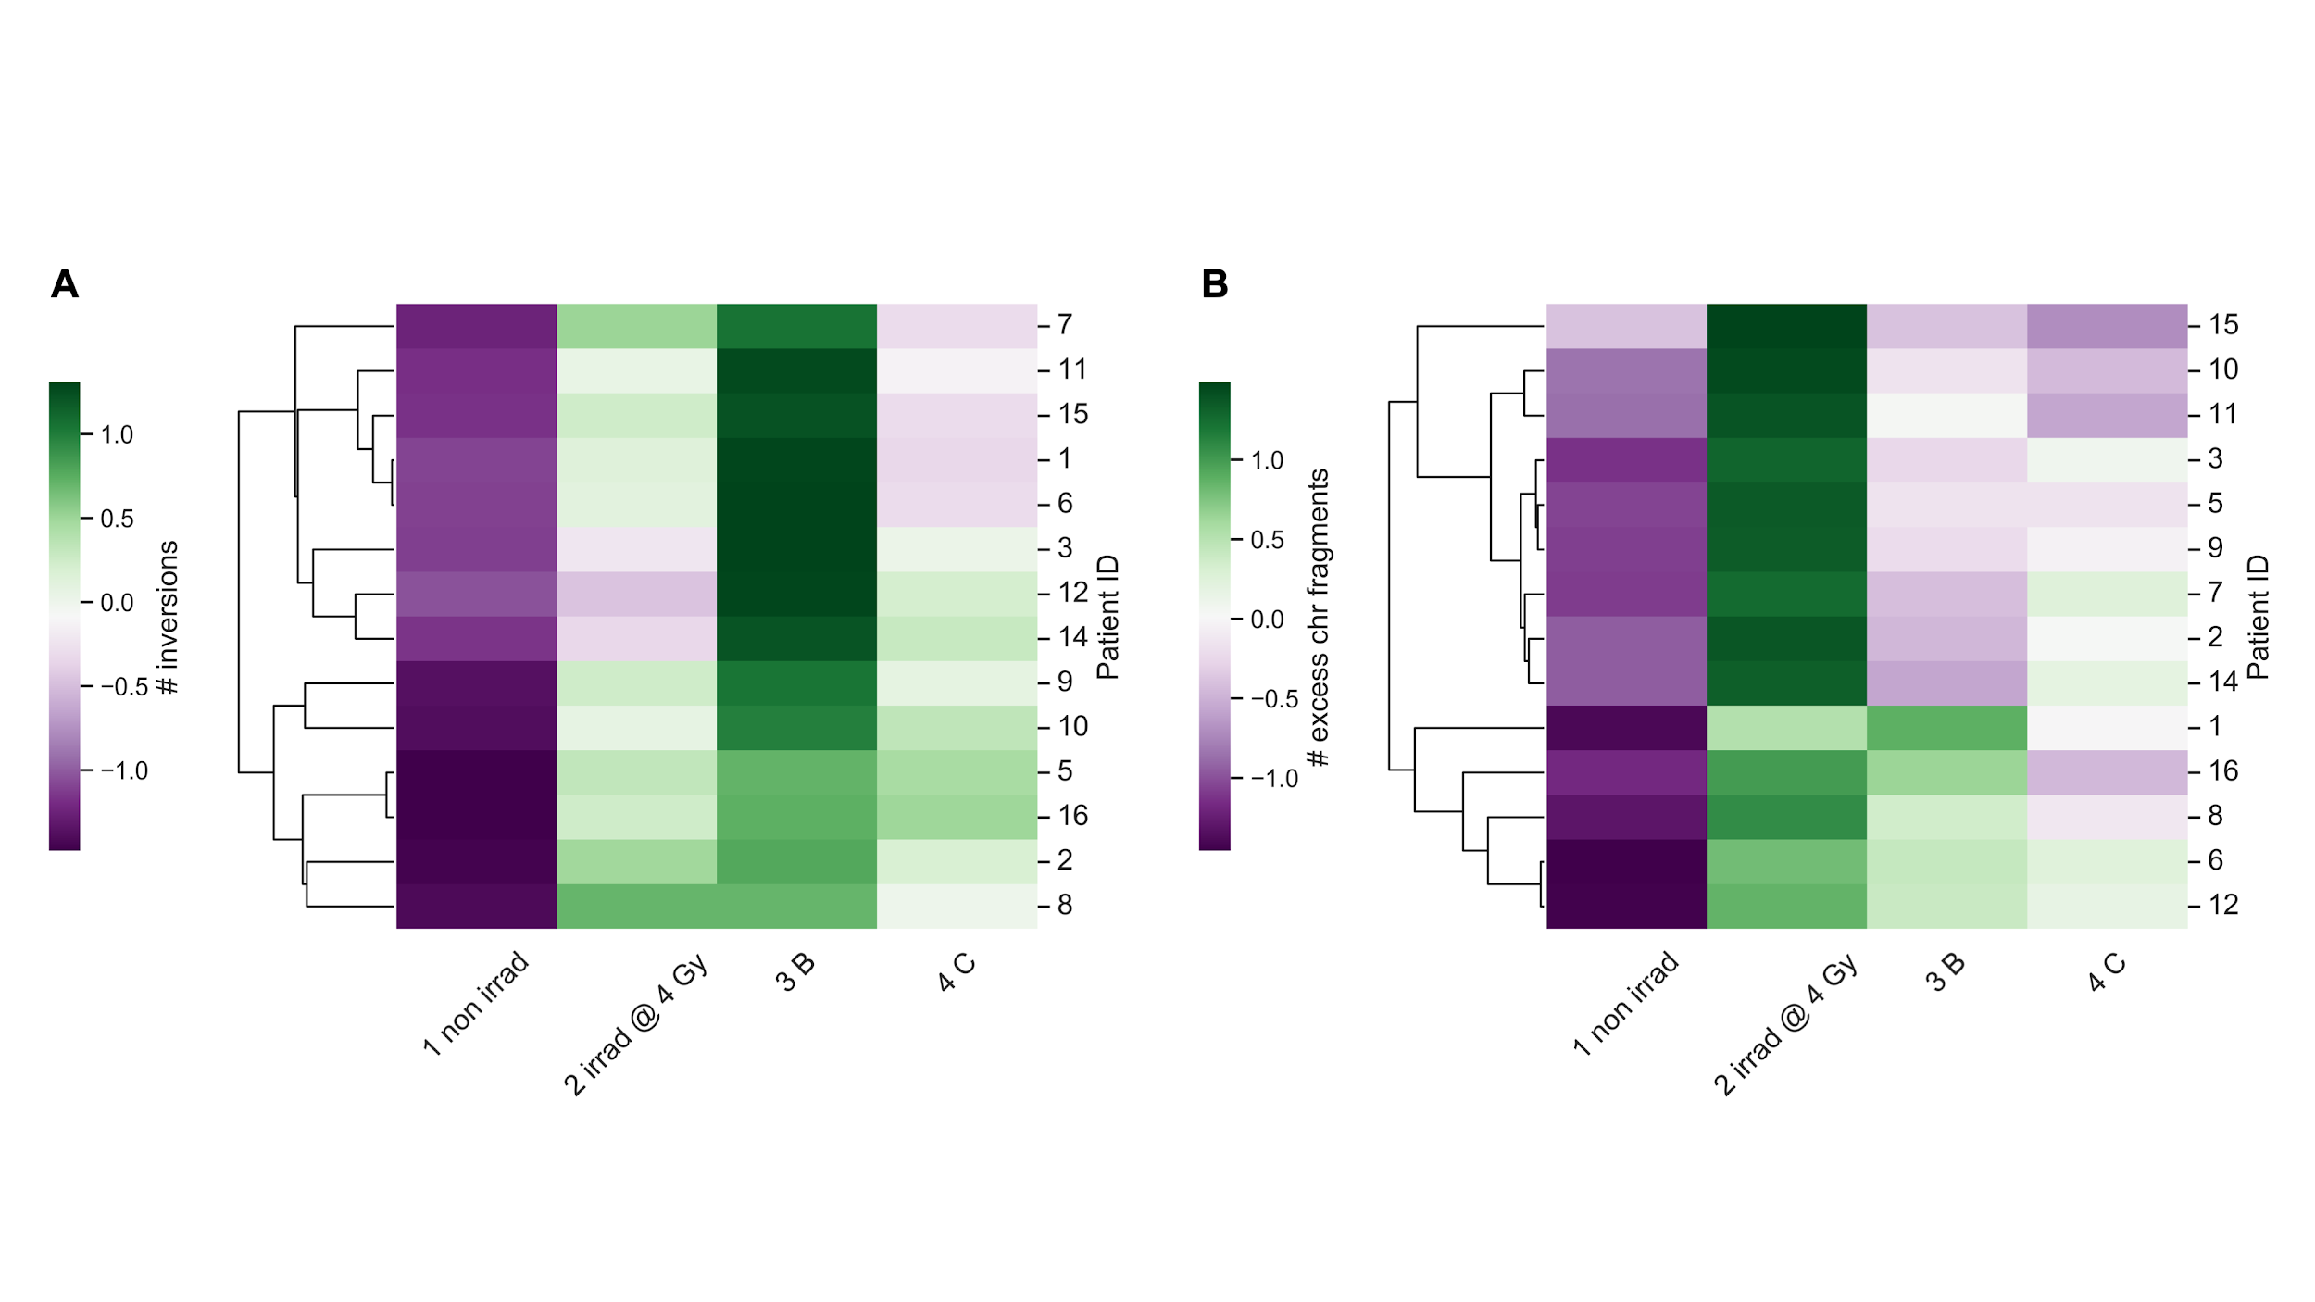

**SUPPLEMENTARY Fig 4. Chromosome aberrations generally failed to cluster patients.** Hierarchical clustering of patients by longitudinal changes in chromosome aberrations scored by directional Genomic Hybridization (dGH). 1 non irrad: pre-IMRT non-irradiated; 2 irrad @ 4 Gy: pre-IMRT *in vitro* irradiated; 3 B: immediate post-IMRT; 4 C: 3 months post-IMRT. Aberration index is created by summing all aberrations (inversions, translocations, dicentrics, chromosome fragments) per cell. Patients were clustered by translocations **A**), dicentrics **B**), and aberration index **C**) (z-score normalized). Patient ID 13 not clustered; 3 months post-IMRT sample failed to culture.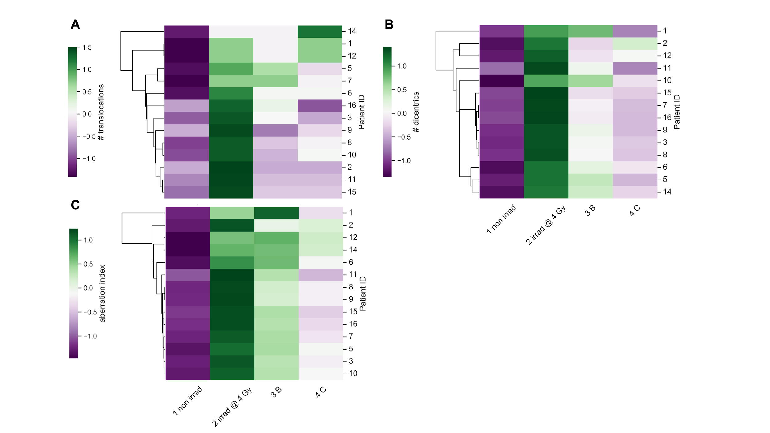

**SUPPLEMENTARY Fig 5. Processing of chromosome aberration data for XGBoost models.** Schematic for machine learning pipeline using chromosome aberration (CAs) data.Preprocessed data: Feature 1: pre-IMRT counts of scored CAs; Feature 2: pre-IMRT sample labels (non-irradiated, *in vitro* irradiated, encoded as 0/1); Feature n: represents pre-IMRT counts of multiple types of CAs (for aberration index). Target: Late post-IMRT average frequencies of CAs (either specific aberration type or aberration index). Data is randomly shuffled and stratified (by patient ID and pre-IMRT sample origin) and split into training (80%) and testing (20%) datasets; patient IDs are stripped after splitting. Five-fold cross validation was used, and models were evaluated with Mean Absolute Error (MAE) and R2 between predicted and true values in the test set. See Materials and Methods and Code availability for model parameters and implementations in Python.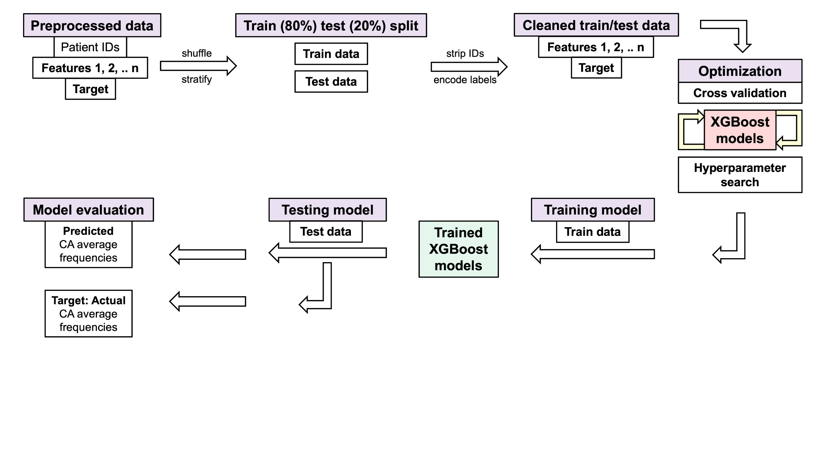

## Supplementary tables:

**SUPPLEMENTARY Table 1. Example views of individual telomere length data matrices used to train XGBoost models.** XGBoost models were trained on 103,040 individual telomere length measurements (one telomere per row) (Telo-FISH) from pre-IMRT non-irradiated (1 non irrad) and *in vitro* irradiated (2 irrad @ 4 Gy) samples to predict 3 months post-IMRT (4 C) telomeric outcomes. Matrices represent examples of pre- (A/C/E) and post-processed (B/D/F) training data. Patient IDs are stripped after data is shuffled and stratified. The ‘encoded sample origin’ column contains numerical encodings denoting individual telomeres’ pre-IMRT sample of origin (0: non-irradiated, 1: *in vitro* irradiated). XGBoost models were trained to predict mean telomere length (**A**/**B**) and numbers of short (**C**/**D**) and long (**E**/**F**) telomeres at 3 months post-IMRT with data in the format as shown.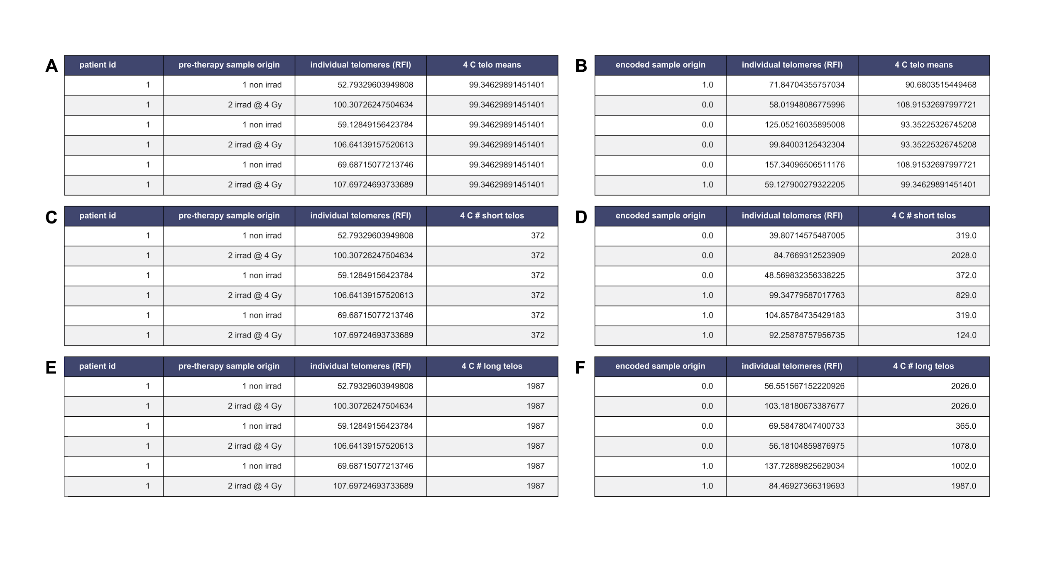

**SUPPLEMENTARY Table 2. Metrics of XGBoost models for predicting post-IMRT telomeric outcomes.** XGBoost models were trained on pre-IMRT individual telomere length measurements (Telo-FISH) to predict 3 months post-IMRT telomeric outcomes. Metrics assess model performance during (five) cross-fold validation (CV) (columns 1-2 from left) and when challenged with the test set (test) (columns 3-4 from left). Model performance was evaluated with mean absolute error (MAE) (std dev: standard deviation) across a range of samples in the training data (n=100 to 103,040). R2: correlation metric. Metrics of XGBoost models for predicting 3 months post-IMRT (4 C) mean telomere length **A**), numbers of short **B**) and long **C**) telomeres.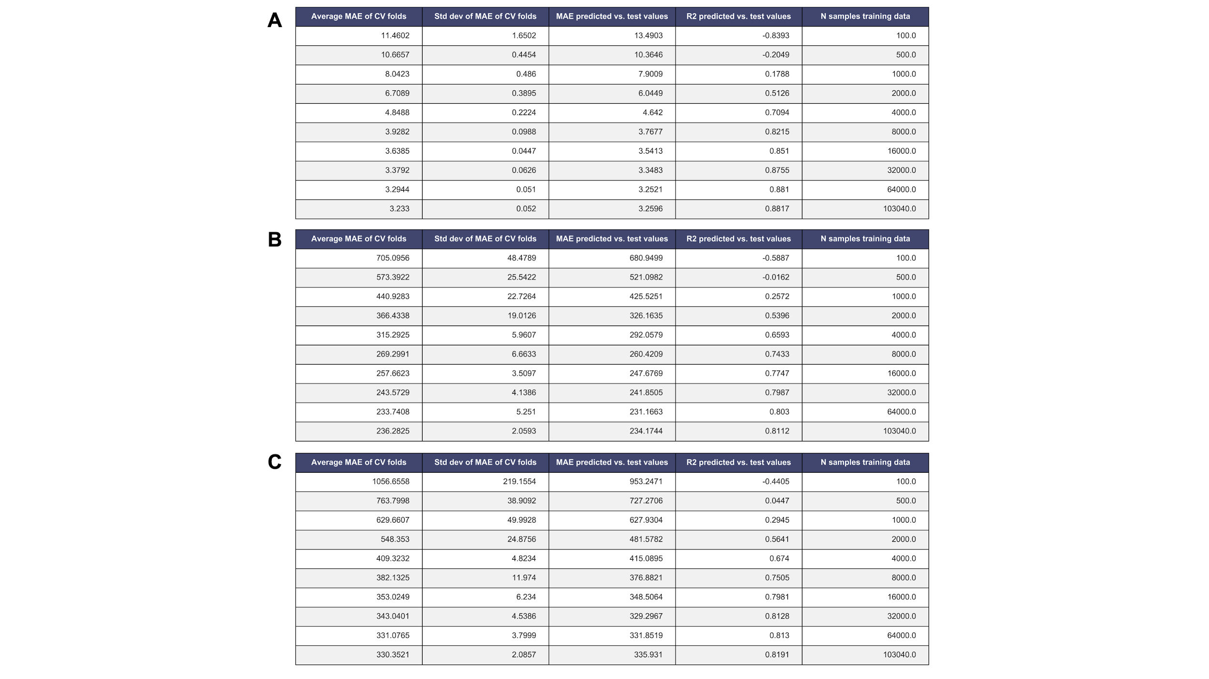

**SUPPLEMENTARY Table 3. Example views of chromosome aberration data matrices used to train XGBoost models.** XGBoost models were trained on chromosome aberration count data (one cell per row, n=672) from pre-IMRT non-irradiated (1 non irrad) and *in vitro* irradiated (2 irrad @ 4 Gy) samples to predict 3 months post-IMRT (4 C) chromosome aberration frequencies. Matrices represent pre- (A/C) and post-processed (B/D) training data. Patient IDs are stripped after data is shuffled and stratified. The ‘encoded sample origin’ column contains numerical encodings denoting cells’ pre-IMRT sample of origin (0: non-irradiated, 1: *in vitro* irradiated). XGBoost models shown were trained to predict average inversion frequencies (**A**/**B**) and aberration index frequencies (**C**/**D**).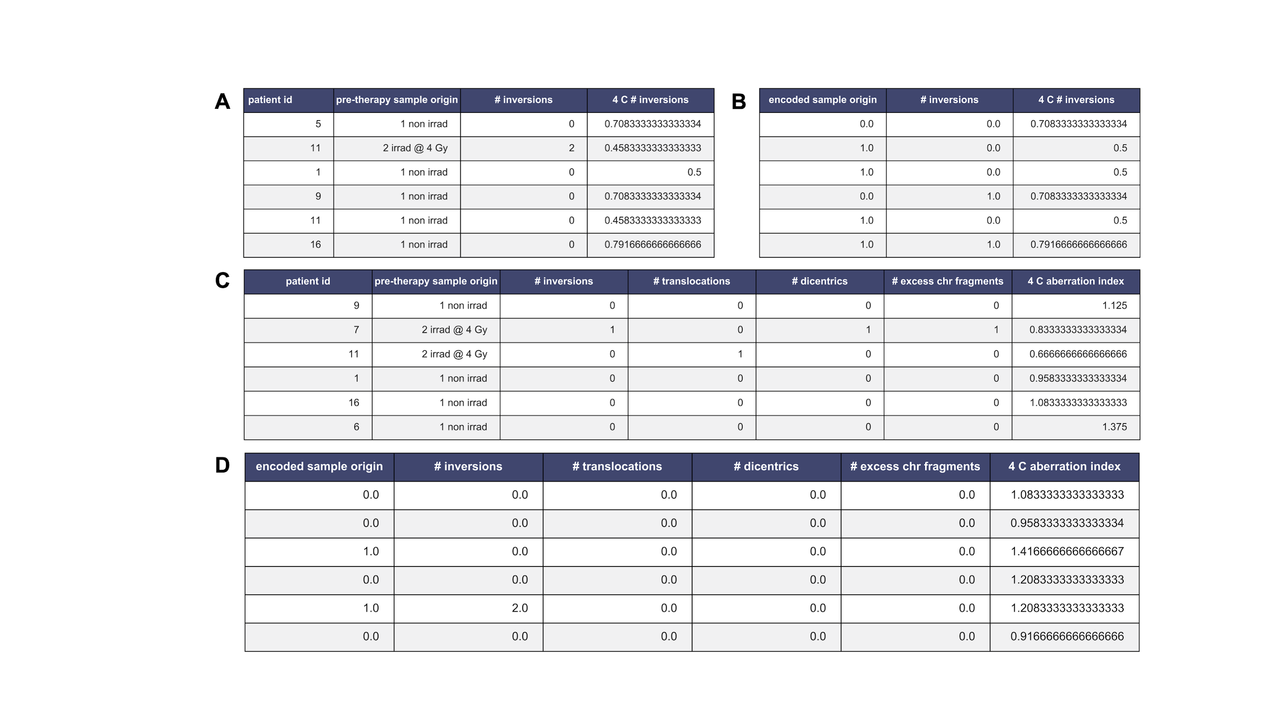

**SUPPLEMENTARY Table 4. Metrics of trained XGBoost models for predicting post-IMRT average frequencies of chromosome aberrations.** Multiple iterations of XGBoost models (A-C) were trained on pre-IMRT chromosome aberration counts per cell (n=672 cells) to predict late post-IMRT average chromosome aberration frequencies. Time points for pre-IMRT data were encoded (0/1: non-irradiated, *in vitro* irradiated). Metrics assess model performance during (five) cross-fold validation (CV) and when challenged with the test set (test). Model performance was evaluated with mean absolute error (MAE) (std dev: standard deviation). R2: correlation metric. Performance of models with identical initializations and hyperparameters for predicting average frequencies of inversions , translocations, dicentrics, chromosome fragments, and aberration index are shown (**A**-**C**).